OAuth Token

🔐 What Is an OAuth Token?
# Source: Chatgpt (GPT-5-Mini) at [1/20/2026]
An OAuth token is a digital credential issued during the OAuth 2.0 authorization process that allows apps to access a user's data without needing their password. It acts like a temporary key.

✅ Simple Definition:
# Source: Chatgpt (GPT-5-Mini) at [1/20/2026]
An OAuth token gives an app permission to access specific parts of a user’s account — like Google Drive or Facebook profile — without revealing the user’s login.

🔄 Types of OAuth Tokens
# Source: Chatgpt (GPT-5-Mini) at [1/20/2026]
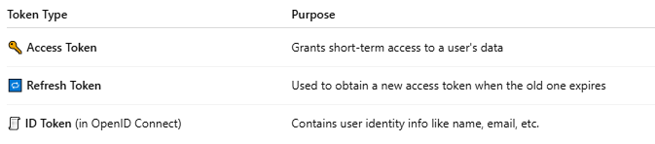

Token Type | Purpose
🔑 Access Token | Grants short-term access to a user's data
🔁 Refresh Token | Used to obtain a new access token when the old one expires
🧾 ID Token (in OpenID Connect) | Contains user identity info like name, email, etc.

🧠 Real-Life Analogy:
# Source: Chatgpt (GPT-5-Mini) at [1/20/2026]
Think of a hotel:
- You give your ID at the front desk (log in)
- They give you a keycard (OAuth access token)
- It opens only your room, not the entire hotel
The card eventually expires, and you need a refresh card (refresh token).

🔐 OAuth 2.0 Flow (Simplified)
# Source: Chatgpt (GPT-5-Mini) at [1/20/2026]
- User logs in to Google (or another OAuth provider)
- OAuth provider asks: “Do you allow this app to access your info?”
- If approved → app receives an Access Token (and sometimes a Refresh Token)
- App uses the Access Token to access resources (e.g., fetch email or files)

🧪 Example Access Token (JWT-style):
# Source: Chatgpt (GPT-5-Mini) at [1/20/2026]
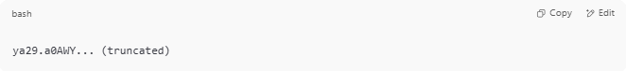
ya29.a0AWY... (truncated)

- May be an opaque string or a JWT
- Passed in requests like this:
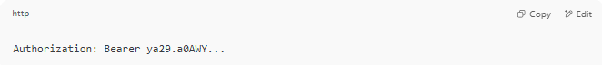
Authorization: Bearer ya29.a0AWY...

🛡️ Key Benefits of OAuth Tokens
# Source: Chatgpt (GPT-5-Mini) at [1/20/2026]
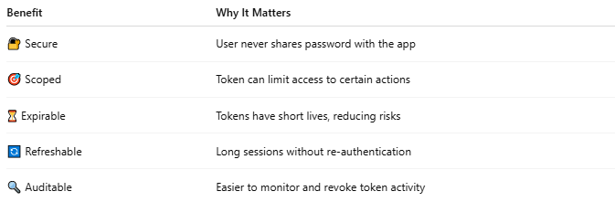

Benefit | Why It Matters
🔐 Secure | User never shares password with the app
🎯 Scoped | Token can limit access to certain actions
⏳ Expirable | Tokens have short lives, reducing risks
🔄 Refreshable | Long sessions without re-authentication
🔍 Auditable | Easier to monitor and revoke token activity

📦 Common OAuth Providers
# Source: Chatgpt (GPT-5-Mini) at [1/20/2026]
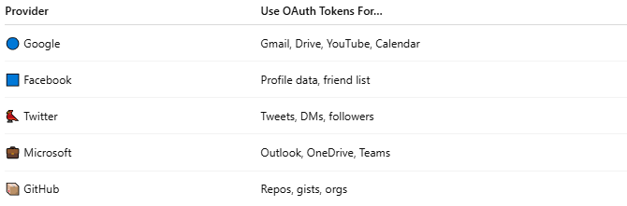

Provider | Use OAuth Tokens For…
🔵 Google | Gmail, Drive, YouTube, Calendar
🟦 Facebook | Profile data, friend list
🐦 Twitter | Tweets, DMs, followers
💼 Microsoft | Outlook, OneDrive, Teams
📦 GitHub | Repos, gists, orgs

⚠️ Security Best Practices
# Source: Chatgpt (GPT-5-Mini) at [1/20/2026]
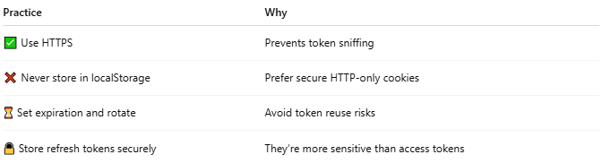

Practice | Why
✅ Use HTTPS | Prevents token sniffing
❌ Never store in localStorage | Prefer secure HTTP-only cookies
⏳ Set expiration and rotate | Avoid token reuse risks
🔒 Store refresh tokens securely | They’re more sensitive than access tokens

📌 Summary
# Source: Chatgpt (GPT-5-Mini) at [1/20/2026]
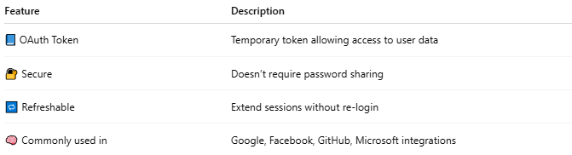

Feature | Description
📘 OAuth Token | Temporary token allowing access to user data
🔐 Secure | Doesn’t require password sharing
🔁 Refreshable | Extend sessions without re-login
🧠 Commonly used in | Google, Facebook, GitHub, Microsoft integrations

